

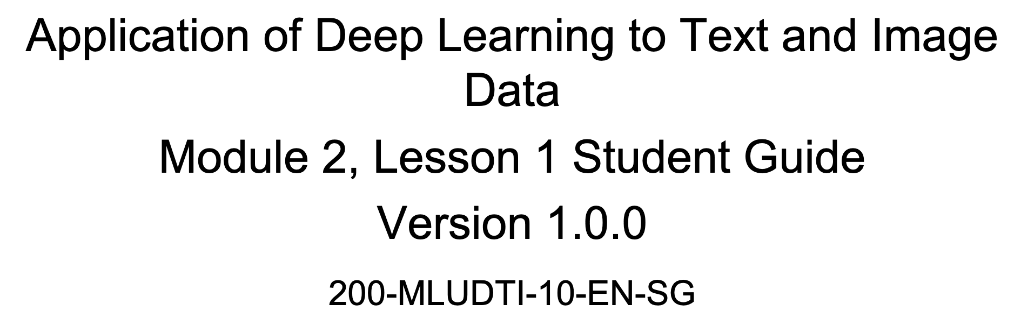

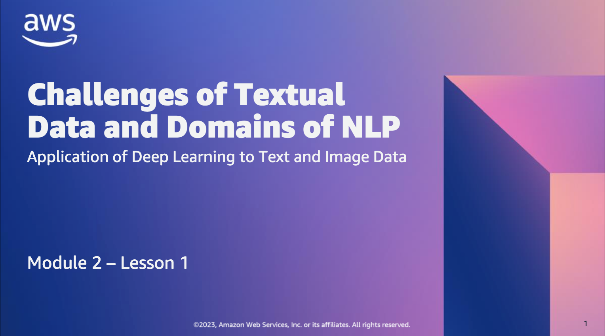

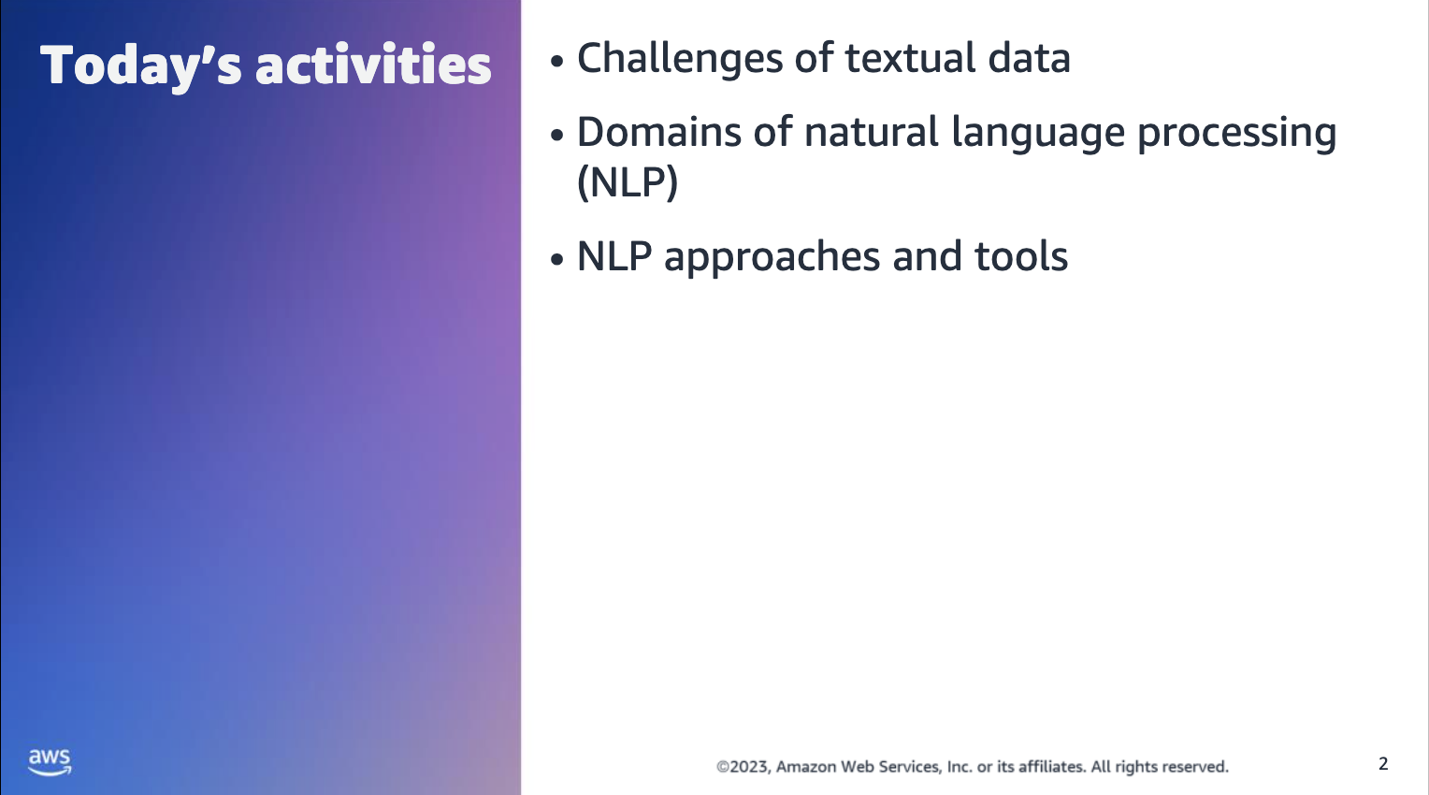

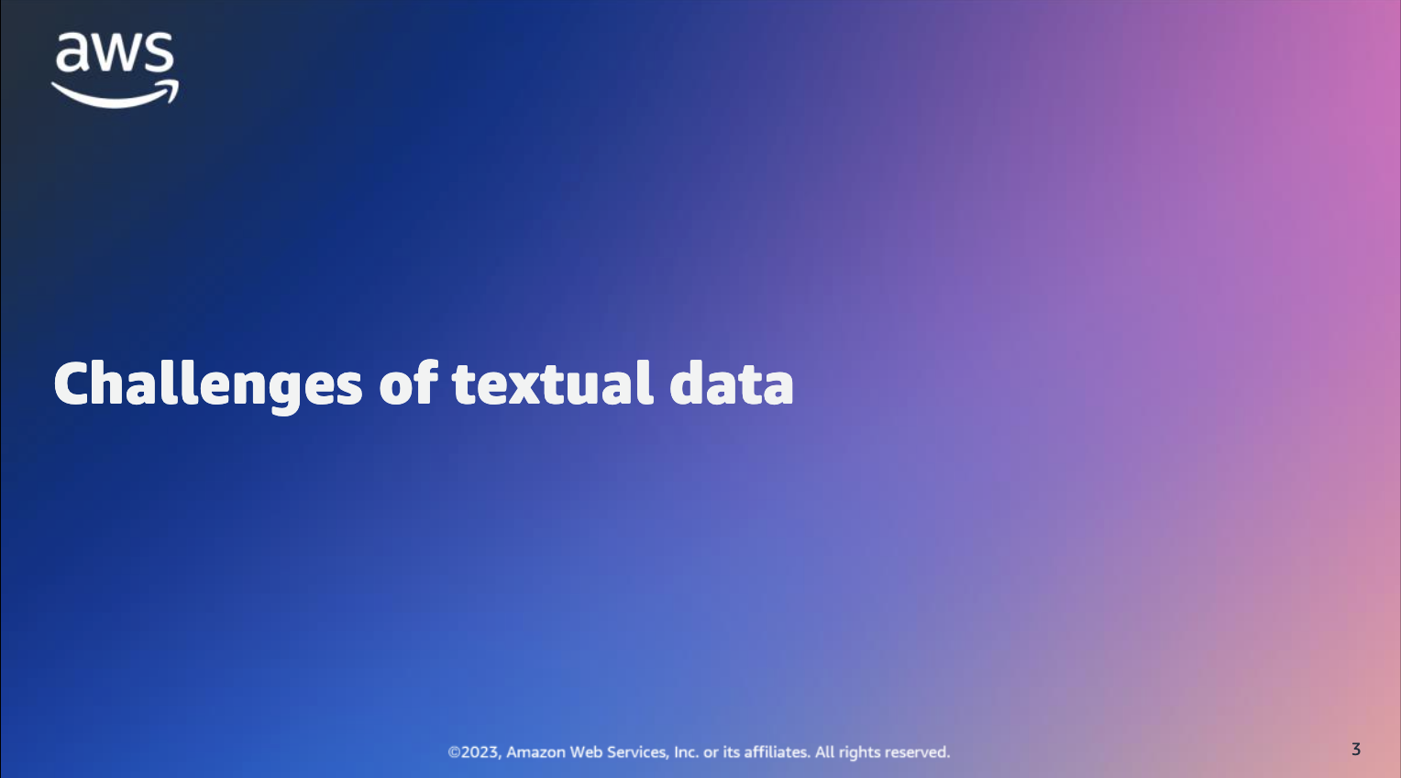

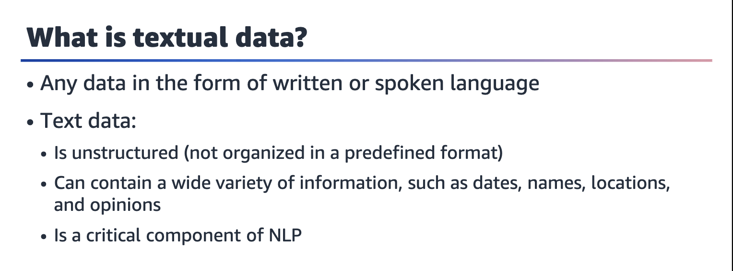

Textual data refers to any data in the form of written or spoken language. It can include emails, social media posts, news articles, product reviews, and more. Textual data is often unstructured, meaning that it isn't organized in a predefined format. It can contain a variety of information, such as dates, names, locations, and opinions.

Textual data is a critical component of natural language processing (NLP), but it poses several challenges that you must address to achieve accurate and useful results.

Challenges include its unstructured nature, linguistic complexity, and data volume.

However, with the correct tools and techniques, you can extract valuable insights and make informed decisions from this rich source of information.

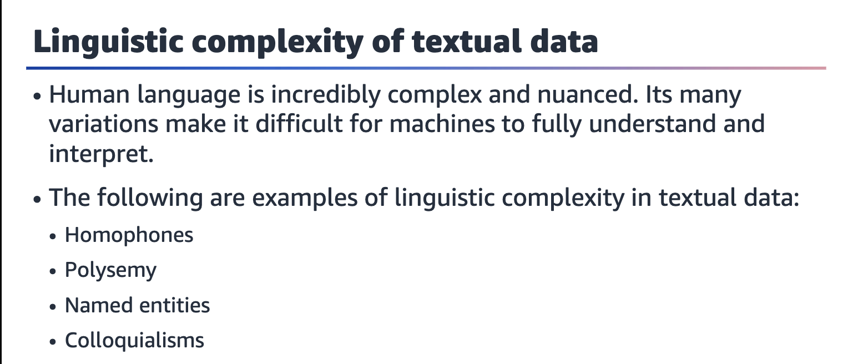

The following are examples of linguistic complexity in textual data:

* Homophones: Words that are pronounced the same but have different meanings, such as there, their, and they're. Machines might struggle to differentiate between these words in text.
* Polysemy: Words with multiple meanings, such as mouse (which can refer to a computer input device or a small rodent). Machines might struggle to determine which meaning is intended in a particular context.
* Named entities: Proper nouns and other named entities (such as places, organizations, and people) can be difficult for machines to identify and disambiguate. For example, the name Washington could refer to a person, a place, or a number of other entities.
* Colloquialisms: Informal language and slang can be difficult for machines to understand. For example, the phrase "I'm gonna bounce" means "I'm going to leave," but this is not immediately obvious from the individual words.

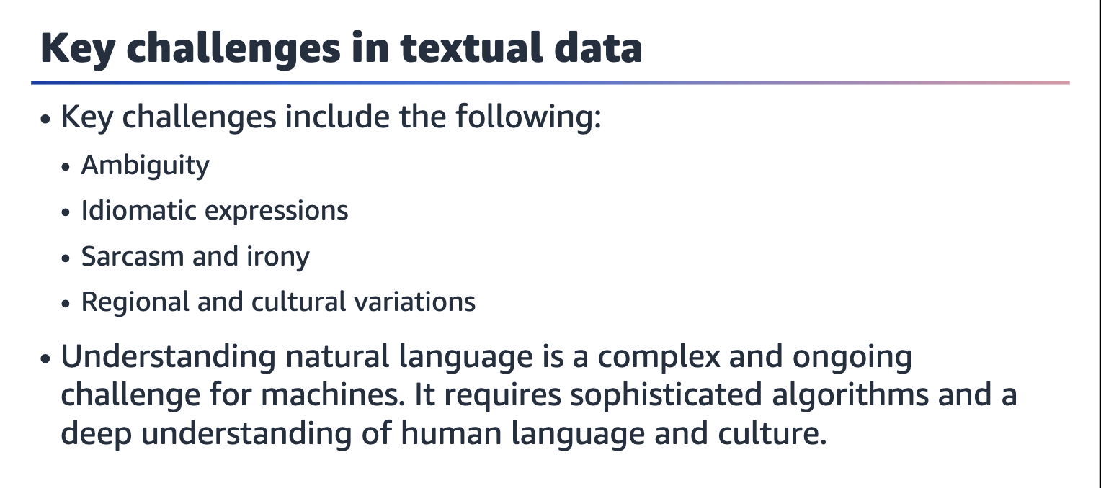

Key challenges in NLP include the following:

* Ambiguity: Many words and phrases can have multiple meanings, depending on context. For example, the word bank can refer to a financial institution, a riverbank, or even a verb meaning to tilt to one side.
* Idiomatic expressions: Many expressions in human language are idiomatic, which happens when their meaning cannot be inferred from the individual words. For example, the phrase "kick the bucket" means to die, but this isn't immediately obvious from the literal meanings of the words.
* Sarcasm and irony: Sarcasm and irony involve saying one thing while meaning the opposite. They are often conveyed through tone of voice and other nonverbal cues. These can be difficult for machines to interpret.
* Regional and cultural variations: Language can vary significantly depending on where it's spoken and who is speaking it. Slang, dialects, and regional idioms can all present challenges for machines that are trying to understand natural language.

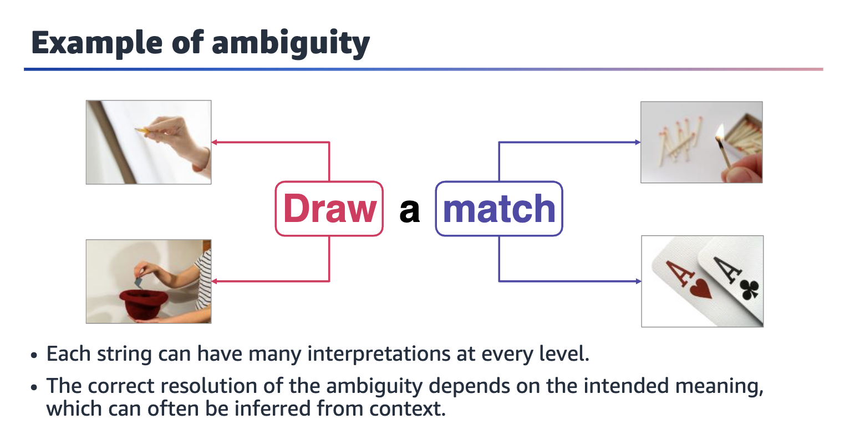

The verb *draw* could mean to produce a picture of something or to pull something out of a receptacle. The noun *match* could refer to a short, thin piece of wood that's used to light a fire or to two things that closely resemble one another.﻿﻿

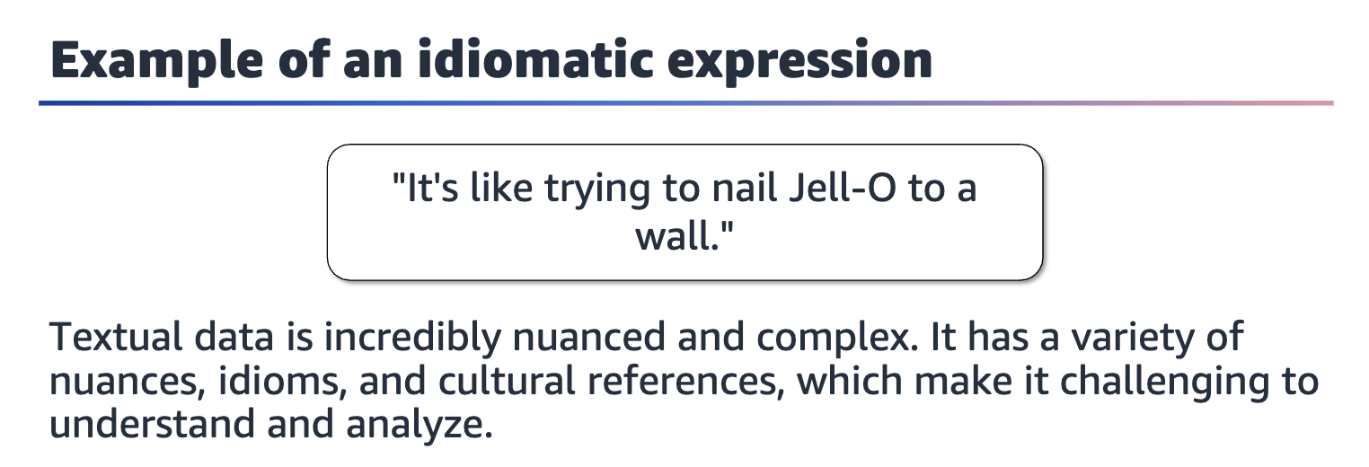

This expression is often used to describe a task that is almost impossible to accomplish, much like managing the complexities of NLP. Similar to how Jell-O is slippery and difficult to handle, natural language is incredibly nuanced and complex.

Its variety of nuances, idioms, and cultural references make it challenging to understand and analyze. Despite the many advances in NLP technology in recent years, it remains a difficult task that requires a great amount of expertise and resources to achieve accurate results.

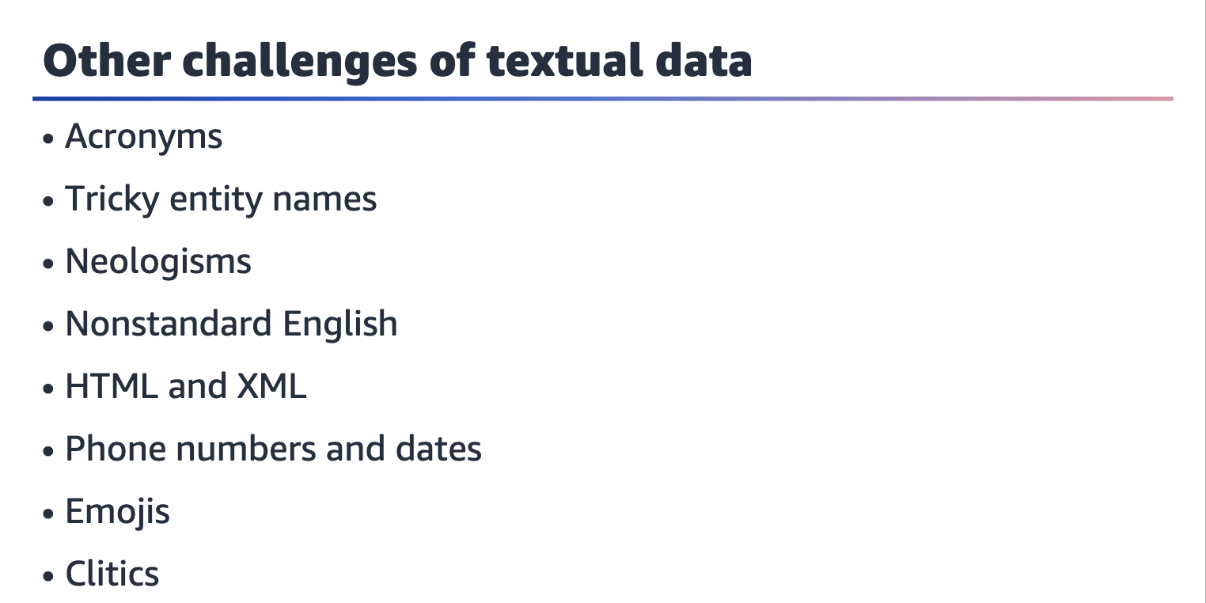

The same meaning can be expressed in many ways, and there are immeasurable meanings to express. In addition to the challenges on the previous slide, think of other ways in which you use language that might be difficult for a machine to understand.

Consider the following examples:

* Acronyms: Acronyms require context and aren't universally known. For example, IP could mean "intellectual property" or "internet protocol."
* Tricky entity names: For example, to interpret the phrase "Where is A Bug's Life playing?", you need to understand that A Bug's Life is a movie title, and playing refers to being shown in a theatre.
* Neologisms: This includes newly invented terms, such as unfriend.
* Nonstandard English: For example, someone might write "s00000 loooong" for "so long."
* HTML and XML: To interpret HTML or XML, you need to understand which parts are HTML or XML tags, recognize special characters, and handle URL formatting.
* Phone numbers and dates: These can be presented in different formats, and standards are different across the world.
* Emojis: Emojis can have different meanings based on context.
* ﻿﻿Clitics: A clitic is an unstressed word that usually only appears with another word; for example, I'm or we're.

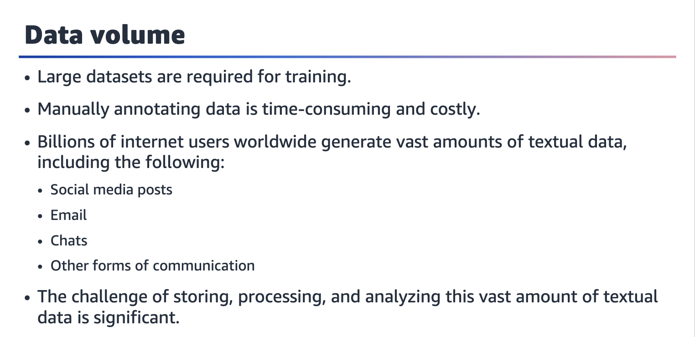

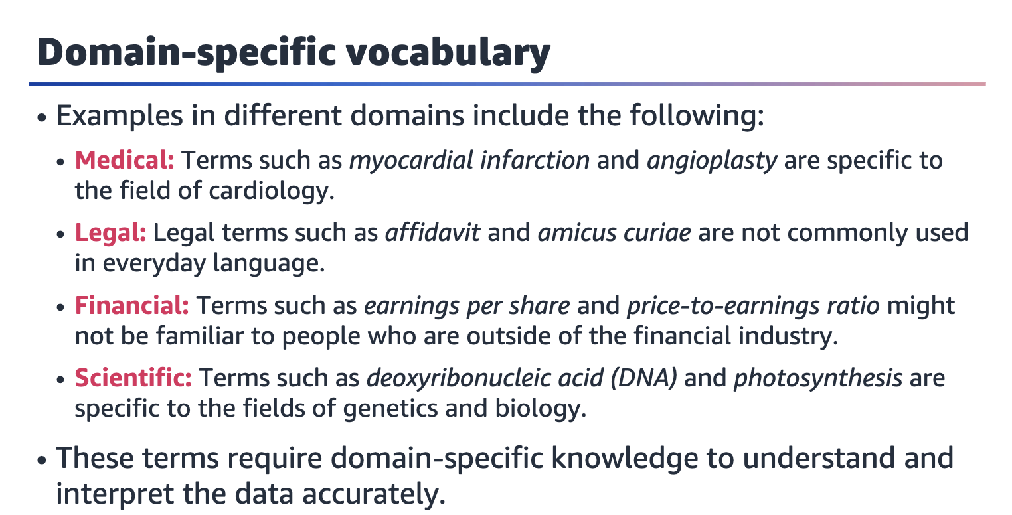

Domain-specific vocabulary refers to the specialized language that is used in a particular field or industry. This language might not be familiar to people who are outside of that field.

Examples of domain-specific vocabulary in different domains include the following:

* ﻿﻿Medical: A large number of technical terms, acronyms, and abbreviations are specific to the field of medicine.
* ﻿﻿Legal: The legal domain has a unique vocabulary.
* ﻿﻿Financial: A large number of technical terms and acronyms are specific to the financial industry.
* ﻿﻿Scientific: A large number of technical terms and acronyms are specific to fields such as chemistry, biology, and physics.

NLP techniques such as entity recognition, named entity recognition, and topic modeling can be used to identify and analyze domain-specific vocabulary in textual data.

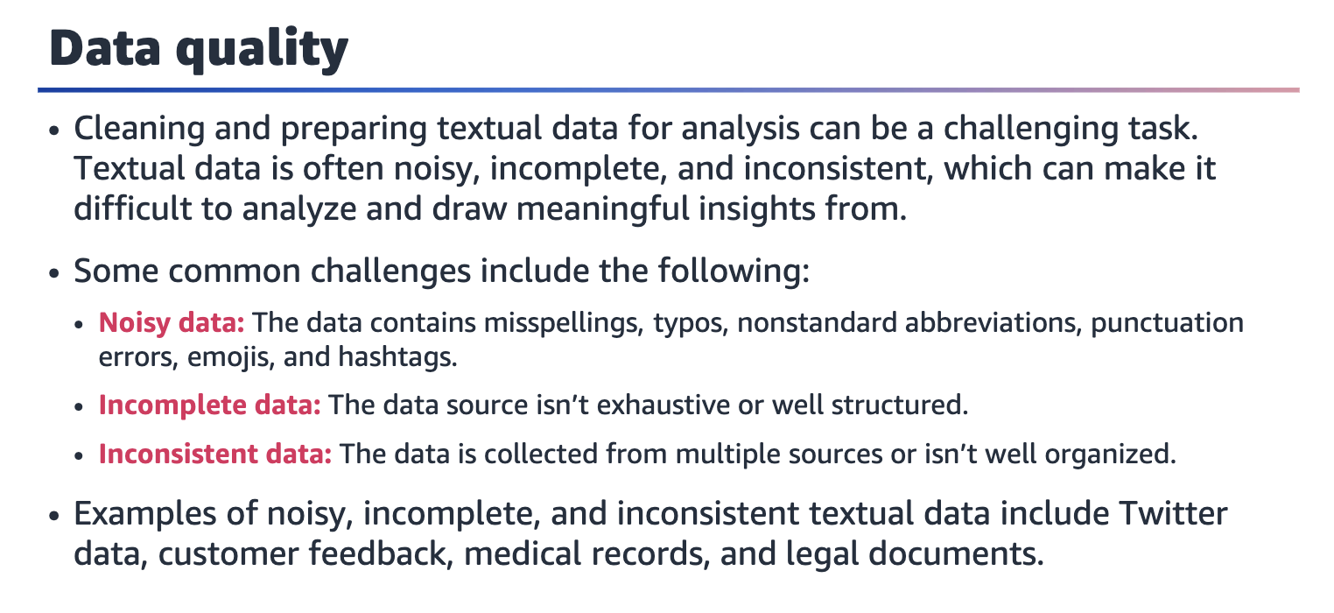

Some of the common challenges in cleaning and preparing textual data for analysis include the following:

* ﻿﻿. Noisy data: Noisy data is contains irrelevant or unwanted information that can obscure or mislead the analysis. Noisy data can include misspellings, typos, nonstandard abbreviations, and punctuation errors. For example, social media data might include emojis, hashtags, and misspellings that can make it difficult to accurately interpret the intended meaning.
* ﻿﻿. Incomplete data: Incomplete data is missing information that is needed for analysis. Incomplete data can occur when the data source isn't exhaustive or well structured. For example, in medical records, some of the patient's medical history might not be recorded, which makes it difficult to accurately analyze.
* ﻿﻿Inconsistent data: Inconsistent data contains conflicting or contradictory information. Inconsistent data can occur when data is collected from multiple sources or when data isn't well organized. For example, in customer feedback surveys, some customers might provide feedback that contradicts the feedback of other customers, which makes it difficult to accurately identify patterns.

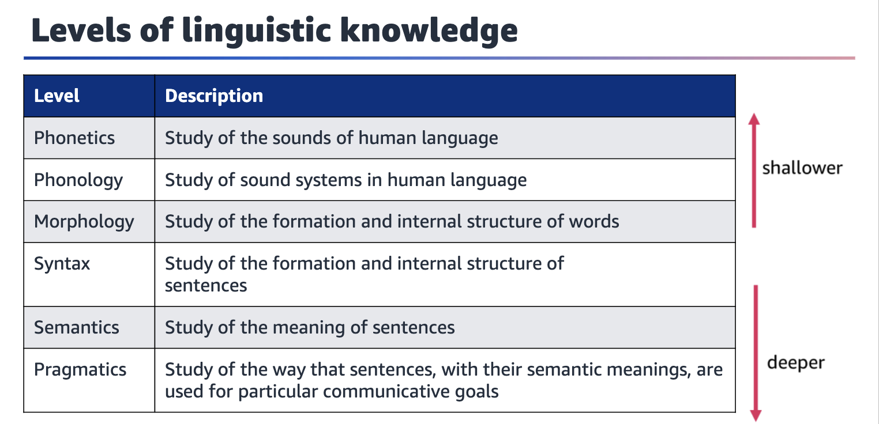

The following are the levels of linguistic knowledge:

* ﻿﻿. Phonetics and phonology are the levels of linguistic knowledge that involve the study of the sounds of language. Phonetics is concerned with the physical properties of speech sounds, while phonology is concerned with the systematic organization of speech sounds in a particular language.
* ﻿﻿. Morphology is concerned with the rules that govern the formation of words and the way in which words are formed from smaller units that are called morphemes.
* ﻿﻿. Syntax is concerned with the rules that govern how words are combined to form phrases and sentences.
* ﻿﻿. Semantics is concerned with the way that words and sentences are used to convey meaning.
* ﻿﻿Pragmatics is concerned with the way that speakers use language to achieve their goals in communication. This field is also concerned with how meaning is affected by context and social factors.

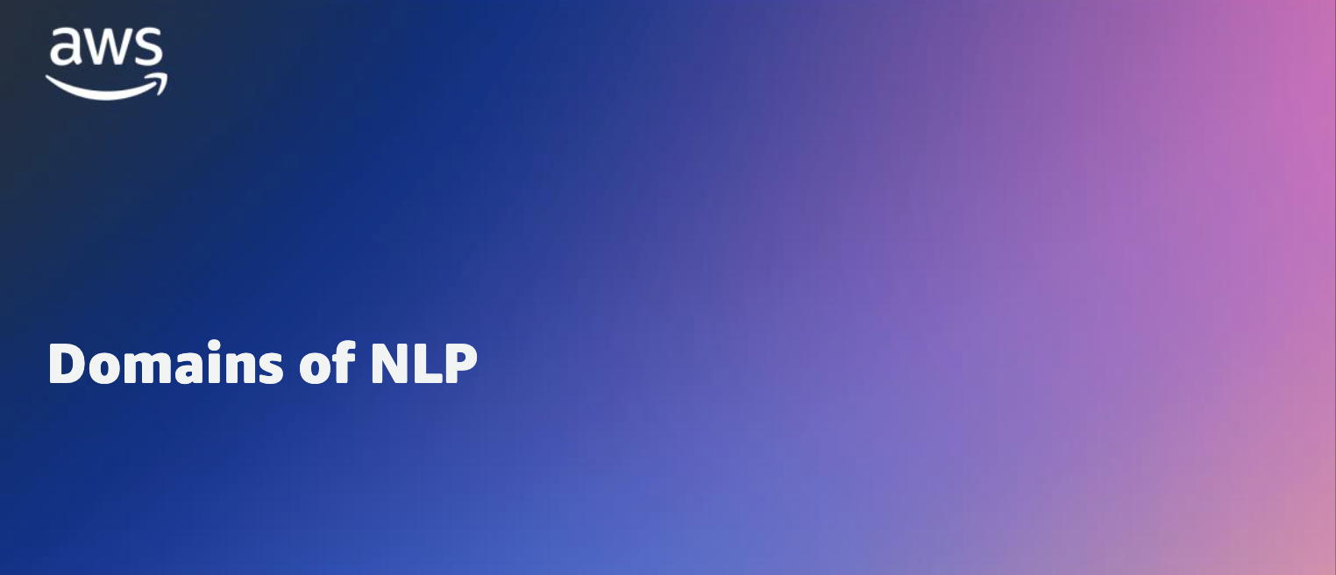

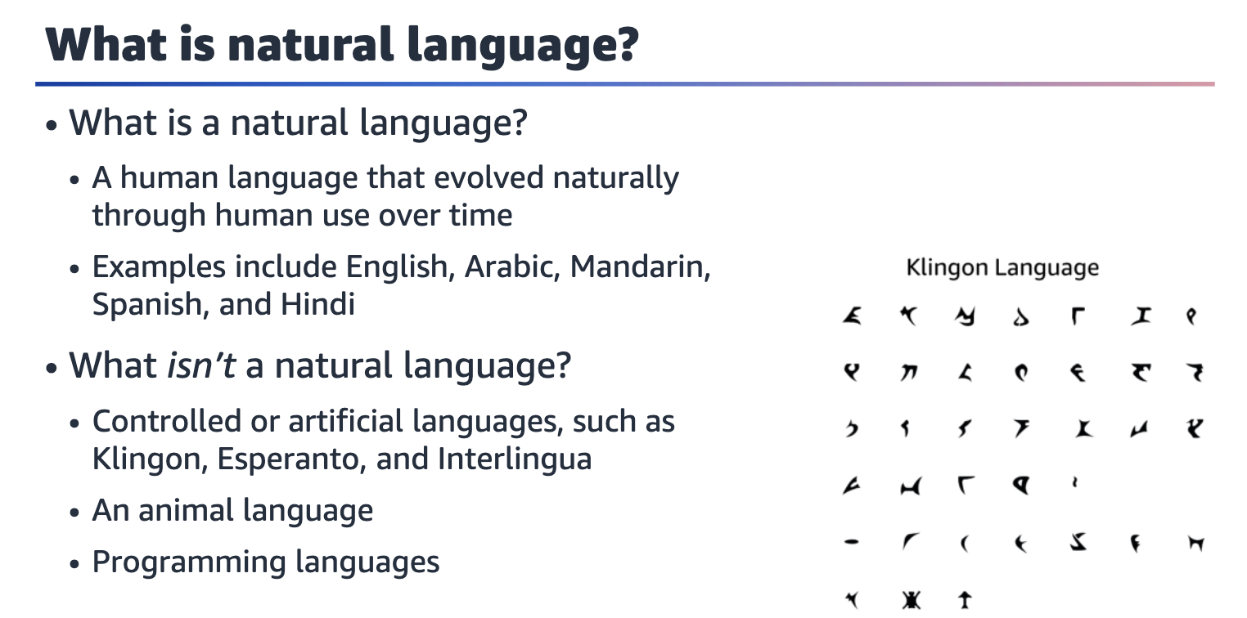

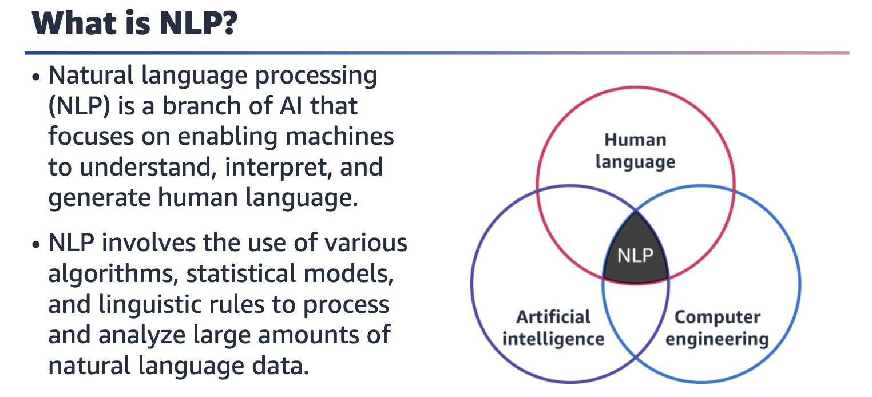

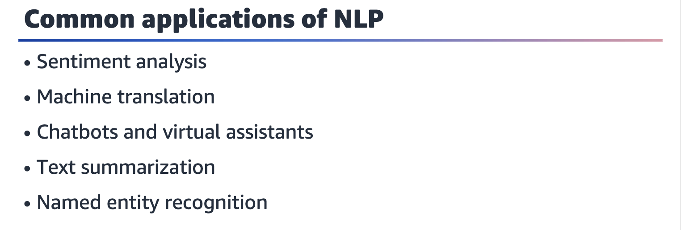

Common applications of NLP include the following:

* ﻿﻿. Sentiment analysis: NLP can be used to analyze large volumes of customer reviews, social media posts, and other text data to determine the overall sentiment or emotional tone of the content. This can help businesses understand customer feedback and improve their products or services accordingly.
* ﻿﻿ Machine translation: NLP can be used to automatically translate text from one language to another. Machine translation is used in a variety of applications, including online language learning platforms, international business communication, and multilingual customer support.
* ﻿﻿. Chatbots and virtual assistants: NLP can be used to build chatbots and virtual assistants that can understand and respond to user queries in natural language. These applications are used in a variety of domains, including customer service, healthcare, and ecommerce.
* ﻿﻿Text summarization: NLP can be used to automatically generate summaries of long text documents, such as news articles or academic papers. This can help users quickly understand the main points of a document without having to read the entire text.
* Named entity recognition: NLP can be used to identify and extract named entities, such as people, organizations, and locations, from large volumes of text data. This can be useful in a variety of applications, including information retrieval and text mining.

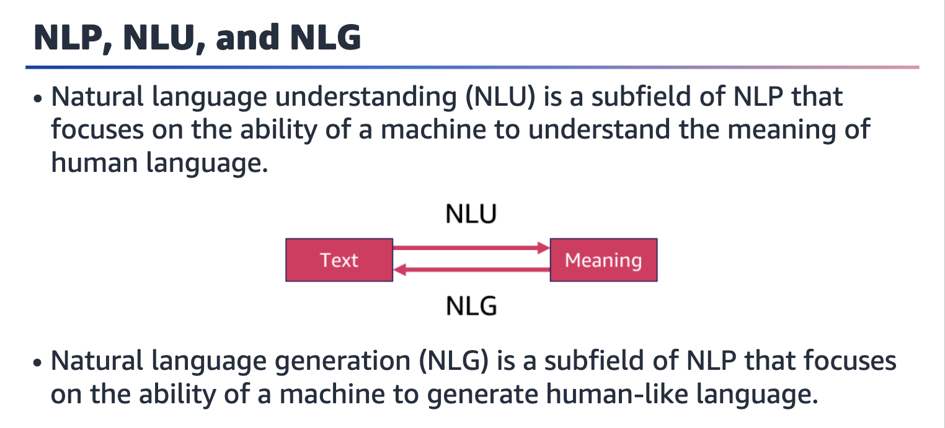

NLU takes human-readable text and provides the meaning to an ML model. NLG uses that derived meaning to provide a human-readable response.

The key difference between NLP, natural language understanding (NLU), and natural language generation (NLG) is the specific focus of each field on different aspects of processing natural language:

* ﻿﻿. Natural language processing (NLP) is a broad field that includes all aspects of processing human language by computers. NLP techniques can be used for a wide range of applications, such as sentiment analysis, speech recognition, and machine translation.
* ﻿﻿. Natural language understanding (NLU) is a subfield of NLP that focuses on the ability of a machine to understand the meaning of human language. NLU techniques extract information from text or speech, understand the intent of a statement, and identify relevant entities or concepts.
* ﻿﻿Natural language generation (NLG) is another subfield of NLP and focuses on the ability of a machine to generate human-like language. NLG techniques create text or speech that is coherent, understandable, and fluent, often based on structured data or other forms of input.

In short, NLP is a general term that encompasses all aspects of processing natural language, while NLU and NLG are more specific subfields that focus on understanding and generating language, respectively.

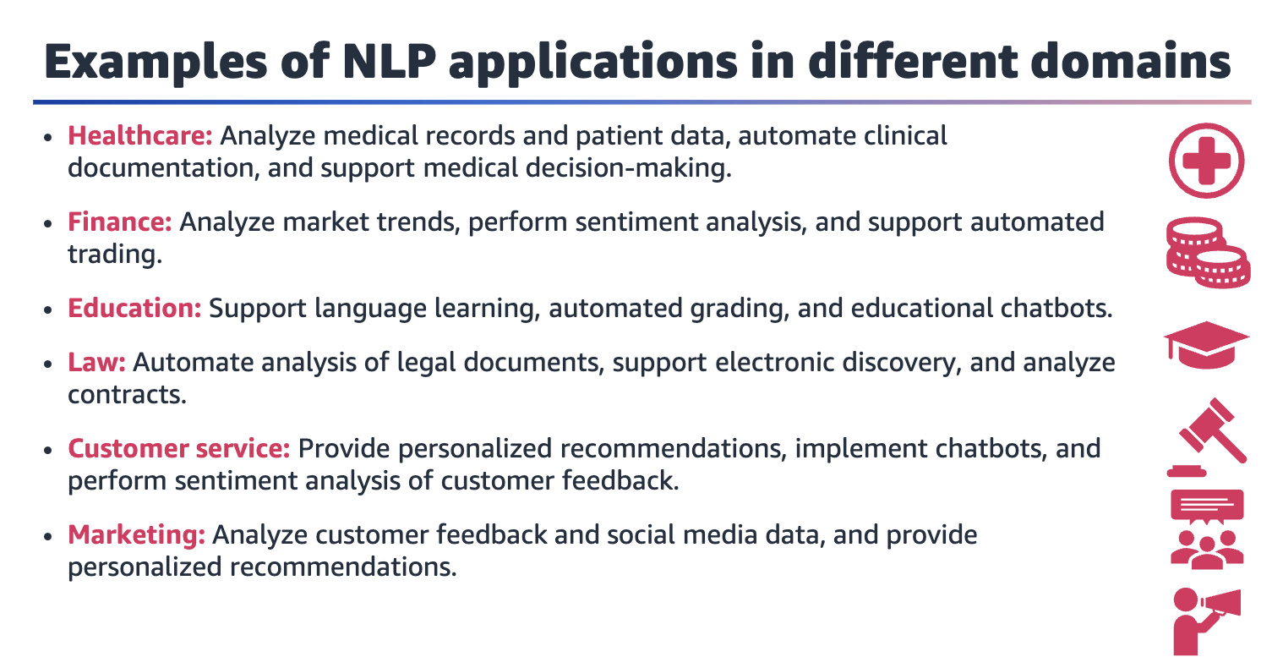

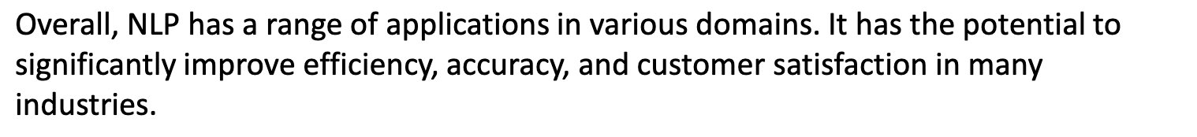

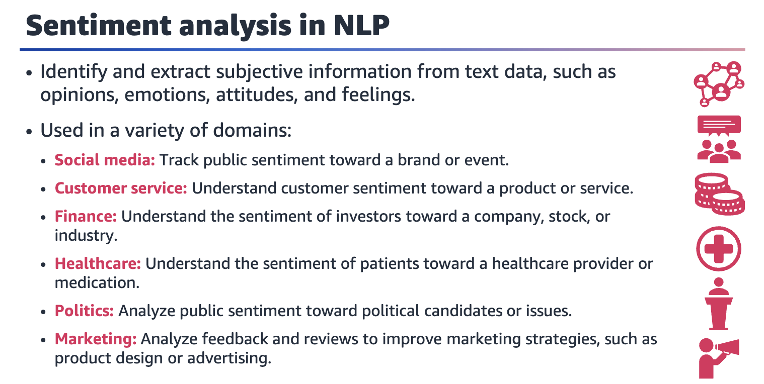

NLP is used for sentiment analysis by automatically identifying and extracting subjective information from text data, such as opinions, emotions, attitudes, and feelings.

Sentiment analysis applications are used in a variety of domains:

* ﻿﻿. **Social media**: Monitor social media posts, such as tweets or Facebook updates, to track public sentiment toward a brand or event.
* ﻿﻿. **Customer service**: Analyze customer feedback and reviews to understand the customer sentiment toward a product or service.
* ﻿﻿. **Finance**: Analyze financial news articles or reports to understand the sentiment of investors toward a company, stock, or industry.
* ﻿﻿. **Healthcare**: Analyze patient feedback and reviews to understand the sentiment of patients toward a healthcare provider or a medication.
* ﻿﻿. **Politics**: Analyze public sentiment toward political candidates or issues.
* ﻿﻿**Marketing**: Analyze customer feedback and reviews to improve marketing strategies, such as product design or advertising.

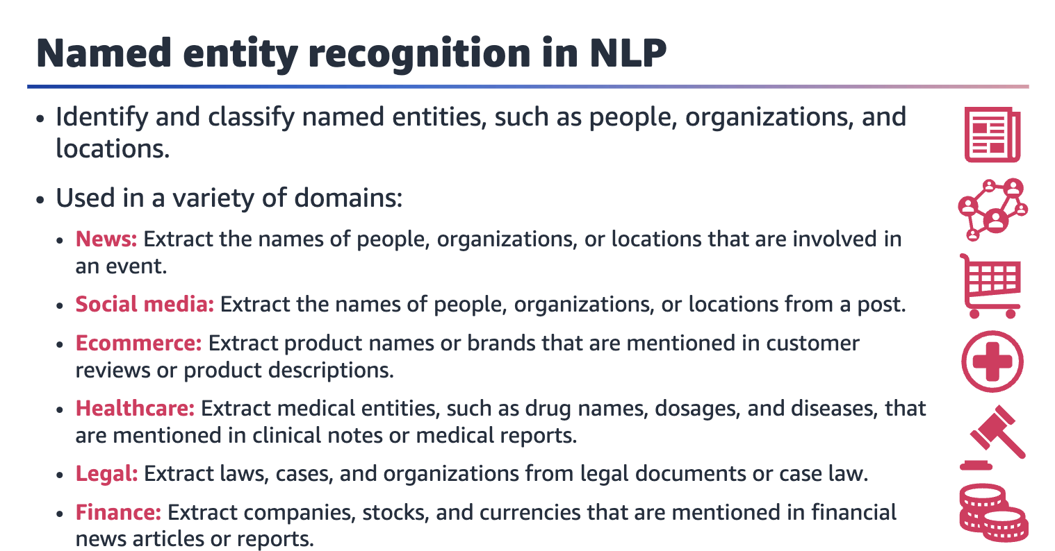

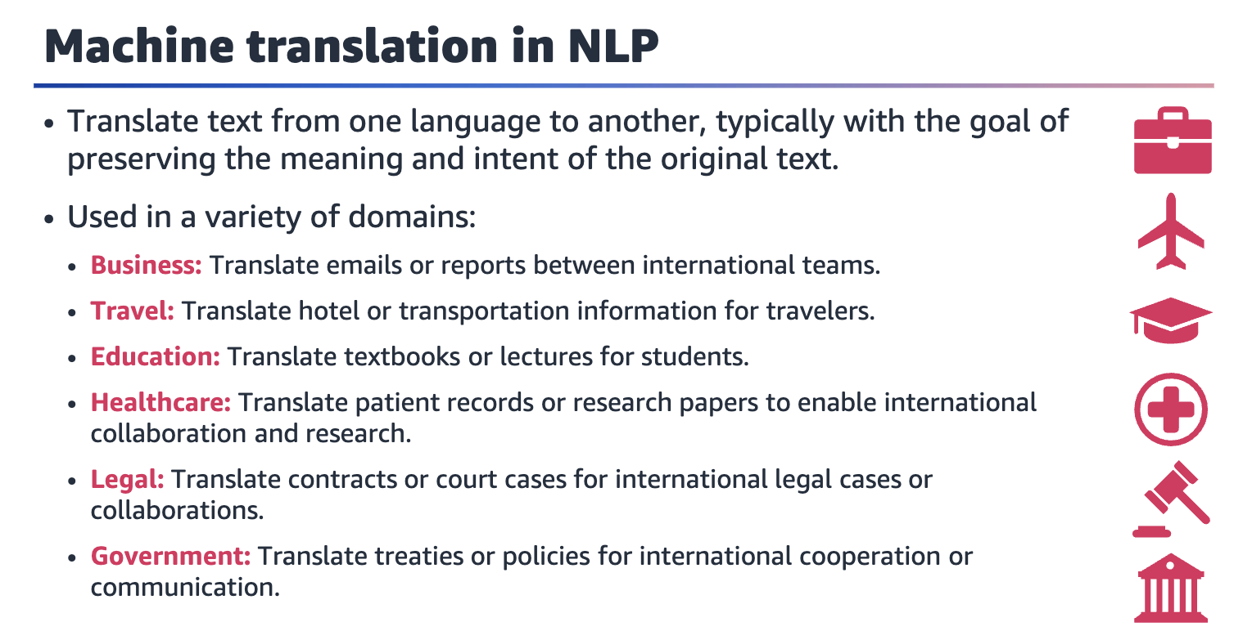

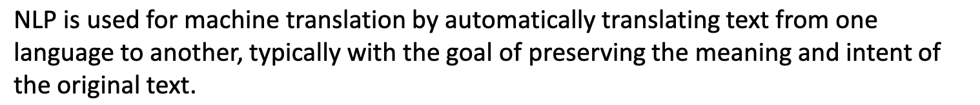

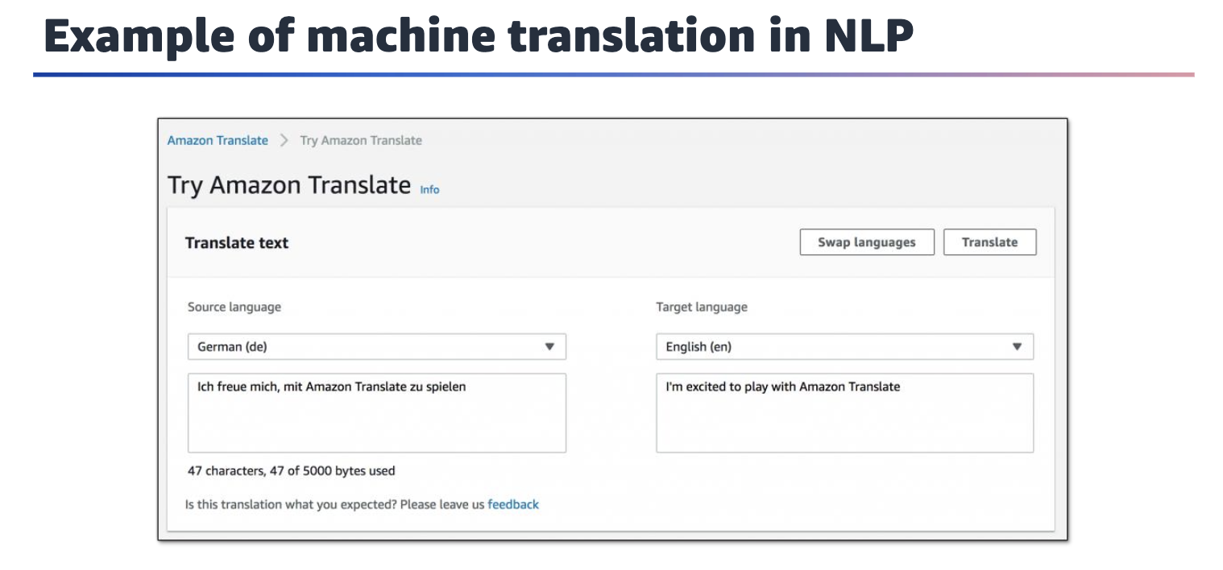

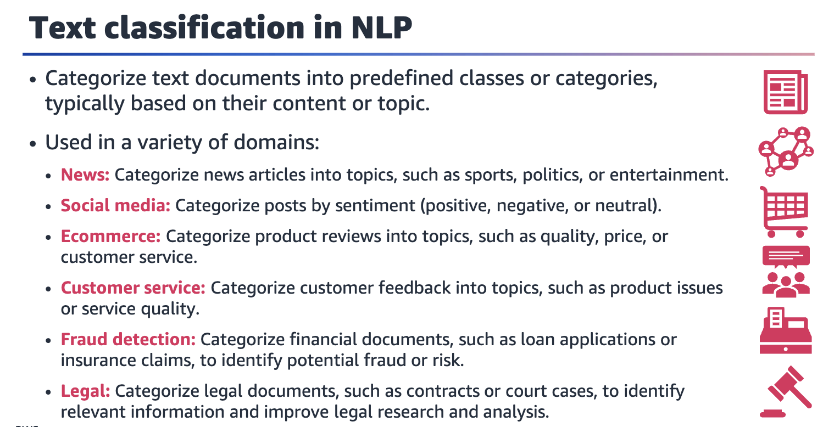



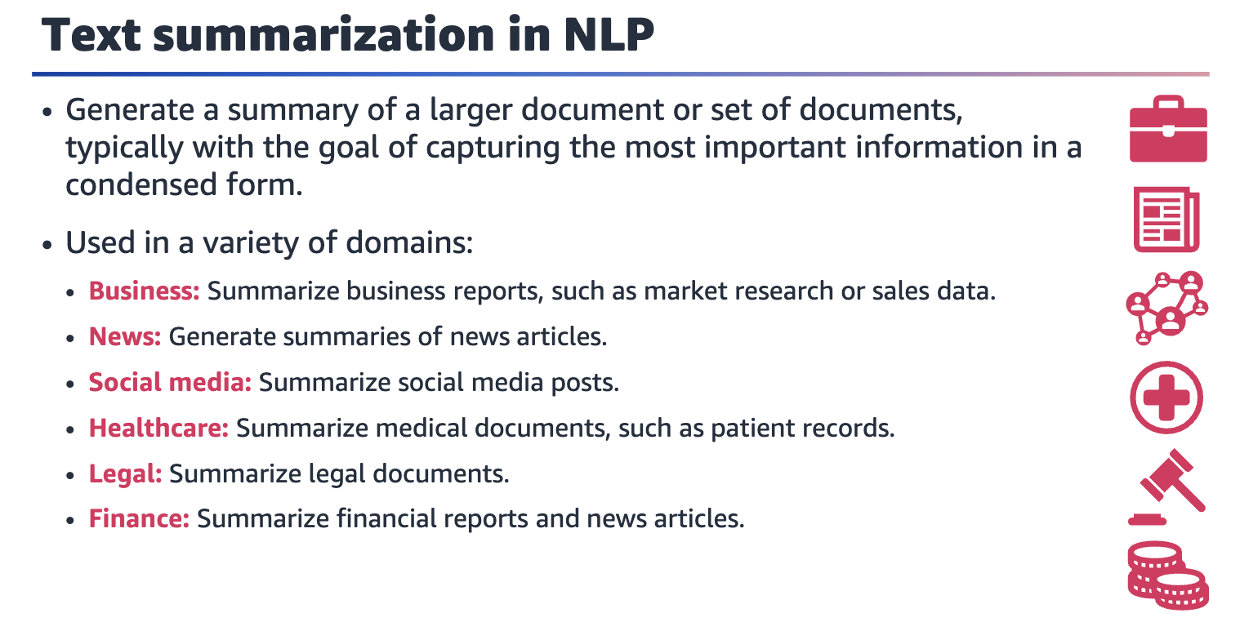

Text summarization applications are used in a variety of domains:

|  |
| --- |
| • Business: Summarize business reports, such as market research or sales data, to enable improved decision-making and planning. |
| • News: Summarize news articles to enable users to quickly understand the main points of a story. |
| • Social media: Summarize social media posts to enable users to quickly understand the most important content. |
| • Healthcare: Summarize medical documents, such as patient records or research papers, to enable improved clinical decision-making and research. |
| • Legal: Summarize legal documents to enable improved legal research and analysis. |
| • Finance: Summarize financial reports and news articles to enable users to quickly understand the most important information and trends. |

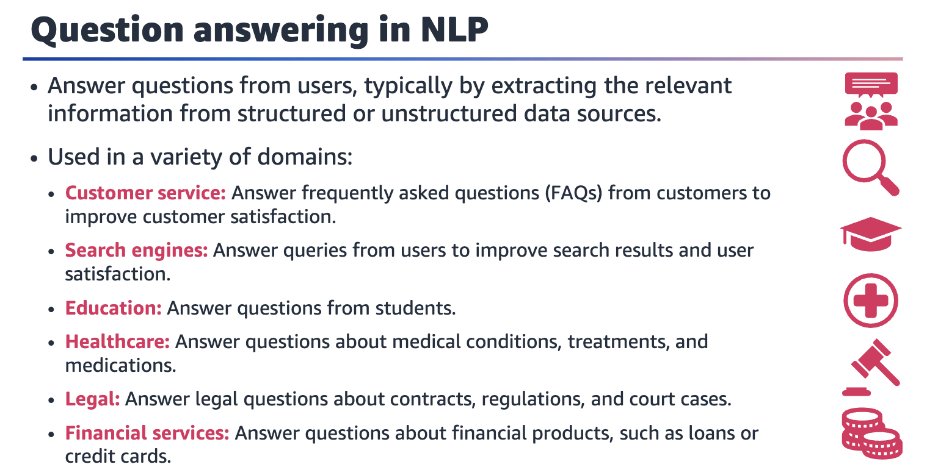

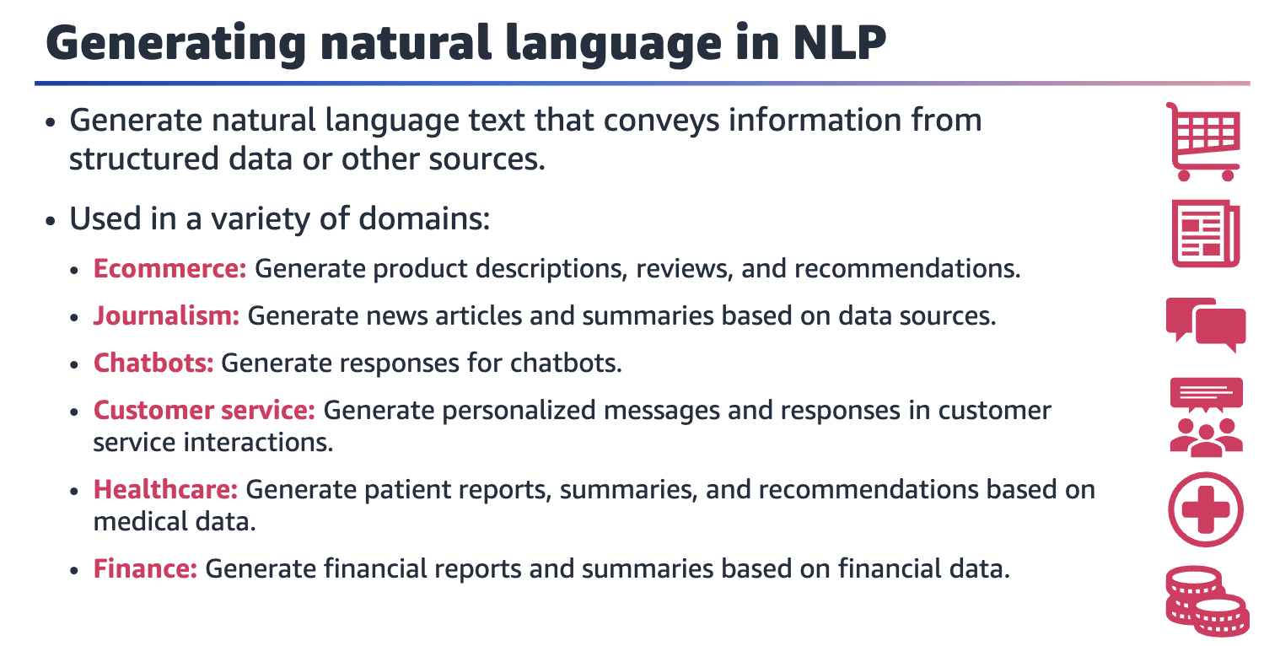

Natural language generation applications are used in a variety of domains:

* ﻿﻿. **Ecommerce**: Generate product descriptions, reviews, and recommendations based on user data to provide personalized product recommendations and improve the customer experience.
* ﻿﻿. **Journalism**: Generate news articles and summaries based on data sources to provide personalized news content and improved journalism.
* ﻿﻿. **Chatbots**: Generate responses for chatbots to provide better human-like interactions and improve customer service.
* ﻿﻿ **Customer service**: Generate personalized messages and responses to improve customer satisfaction and retention.
* ﻿﻿ **Healthcare**: Generate patient reports, summaries, and recommendations based on medical data to improve clinical decision-making and patient outcomes.
* ﻿﻿**Finance**: Generate financial reports and summaries based on financial data to automate financial analysis and reporting.

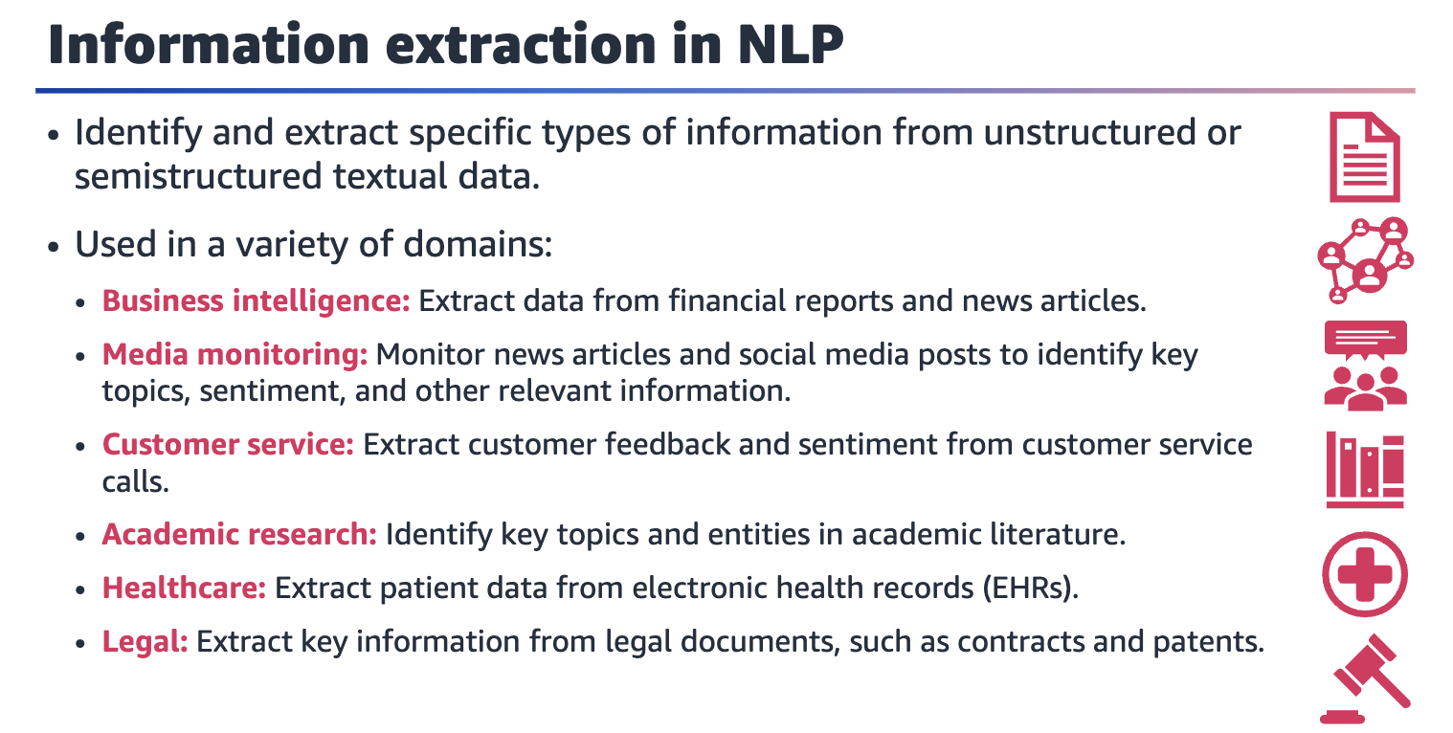

Information extraction applications are used in a variety of domains:

* ﻿﻿. **Business intelligence**: Extract data from financial reports, news articles, and other business documents to automate data analysis and trend analysis.
* ﻿﻿. **Media monitoring**: Monitor news articles and social media posts to identify key topics, sentiment, and other relevant information.
* ﻿﻿. **Customer service**: Extract customer feedback and sentiment from customer service calls to improve customer service and product development.
* ﻿﻿. **Academic research**: Automatically identify key topics and entities in academic literature to help researchers quickly identify relevant articles and research findings.
* ﻿﻿. **Healthcare**: Automatically extract patient data from electronic health records (EHRs) to improve clinical decision-making, population health management, and medical research.
* ﻿﻿**Legal**: Automatically extract key information from legal documents, such as contracts or patents, to improve contract management and legal research.

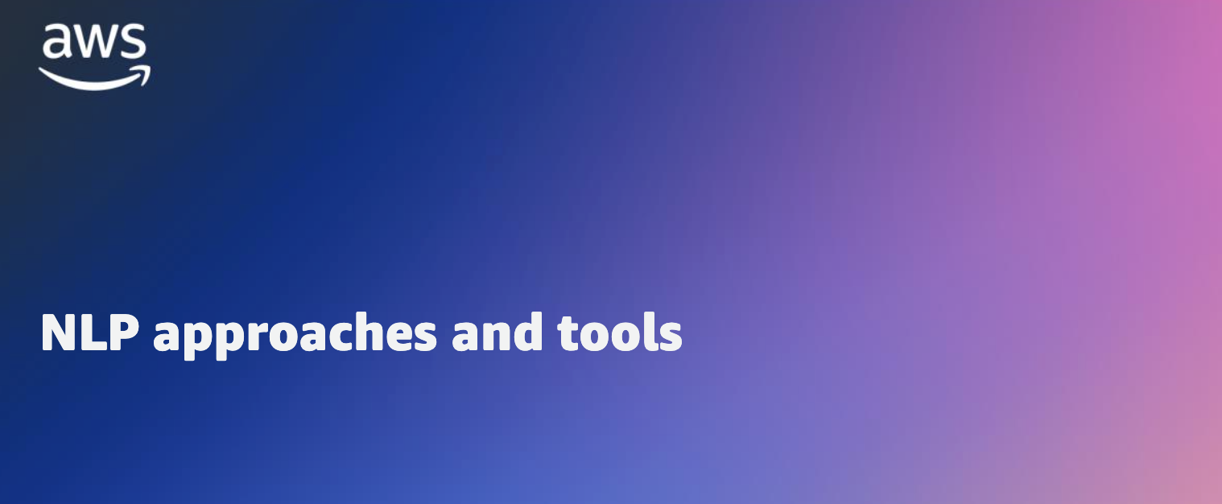

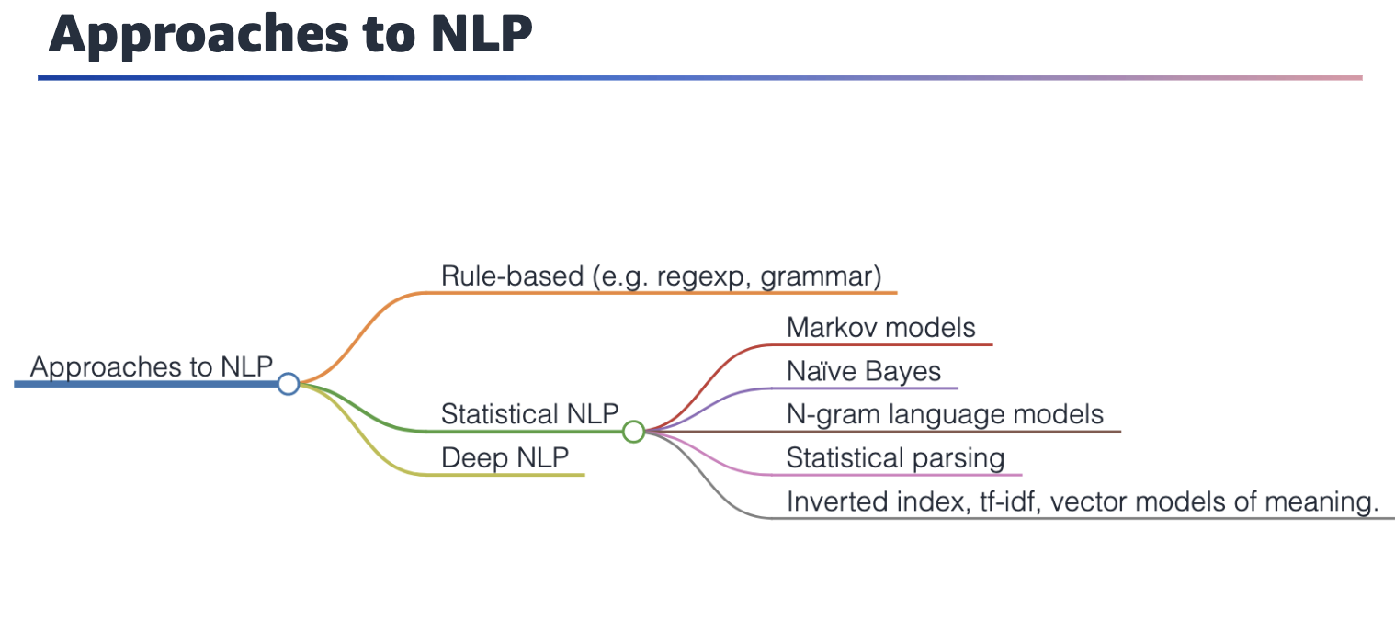

**Rule-based NLP**

Rule-based NLP involves creating a set of handcrafted rules that are applied to text to extract information or perform other tasks. For example, a rule-based NLP system might include rules to identify named entities, such as person names, company names, and locations, by searching for specific patterns of words and symbols in the text.

**Statistical NLP**

Statistical NLP involves using statistical models and ML algorithms to automatically learn patterns in text data. For example, a statistical NLP system might use an ML algorithm, such as a naive Bayes classifier, to classify text as positive or negative sentiment based on the frequency of certain words in the text.

**Deep NLP**

Deep NLP involves using deep neural networks, which are ML models that are composed of multiple layers of interconnected nodes, to analyze text data. Deep NLP models can be highly accurate for a range of tasks and can often learn to generalize to new language variations without requiring as much labeled training data as statistical models. However, deep NLP models can be complex to develop and train, and might require significant computing resources to run efficiently.



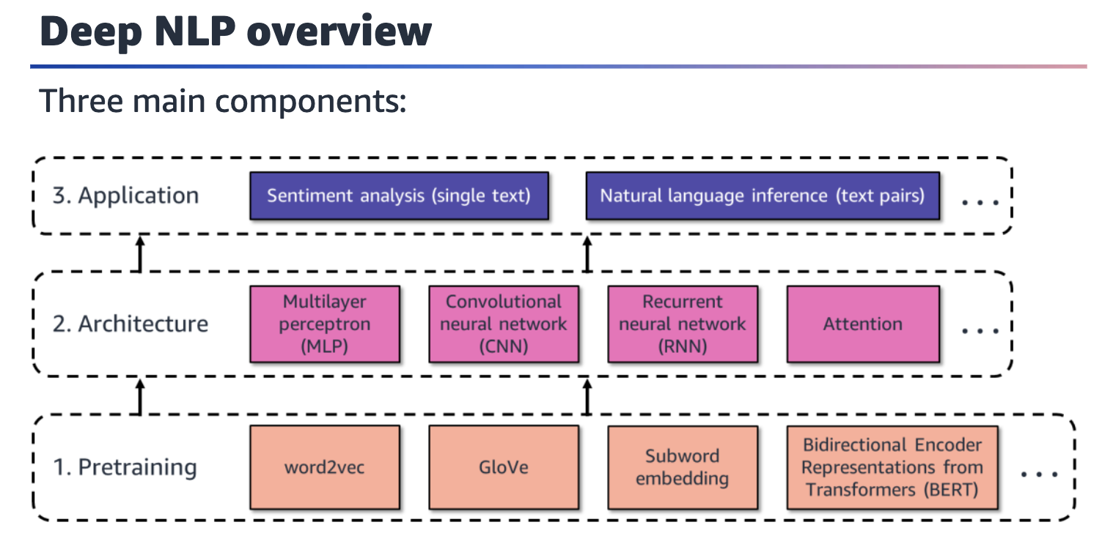

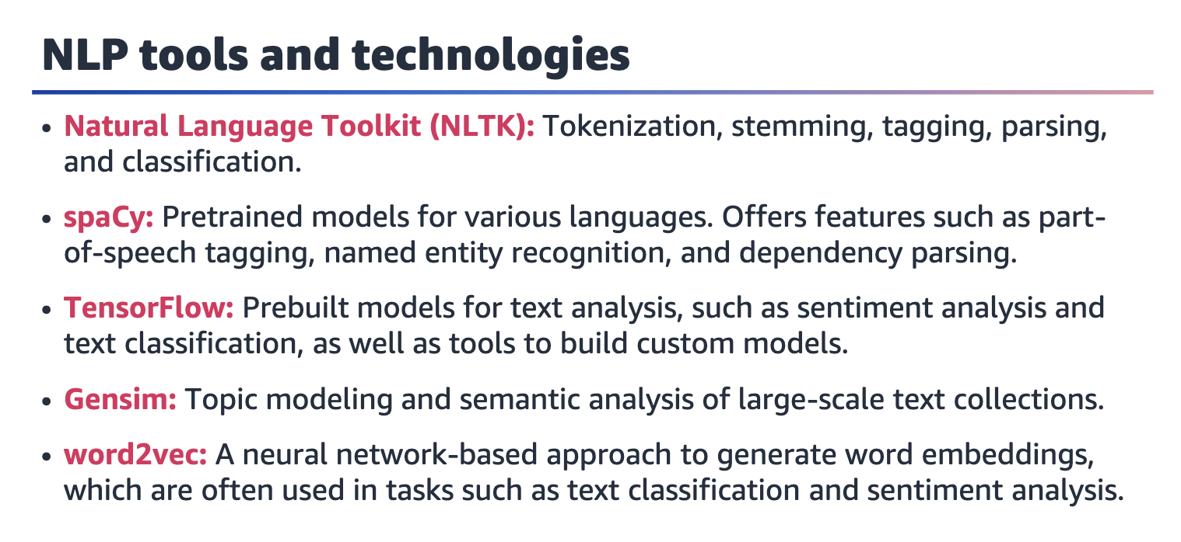

**Natural Language Toolkit (NLTK)** is a popular Python library to work with human language data. The toolkit provides various modules and algorithms for tasks such as tokenization, stemming, tagging, parsing, and classification.

**spaCy** is another popular NLP library for Python, and the library provides fast and efficient processing for natural language. spaCy includes pretrained models for various languages and offers features such as part-of-speech tagging, named entity recognition, and dependency parsing.

**TensorFlow** is an open source ML platform that Google developed. The platform can be used for a variety of tasks, including NLP. It provides a number of prebuilt models for text analysis, such as sentiment analysis and text classification, as well as tools to build custom models.

**Gensim** is a Python library for topic modeling and semantic analysis of large-scale text collections. It includes algorithms for document similarity, topic modeling, and word embedding, among others.

**word2vec** is a neural network-based approach to generate word embeddings, which are numerical representations of words that capture their meaning and context. It is often used in tasks such as text classification and sentiment analysis.

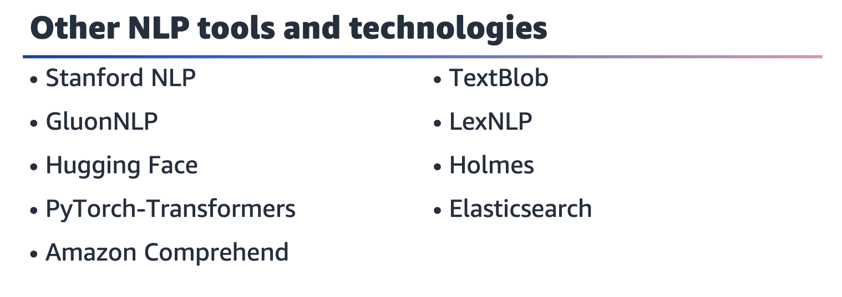

Other NLP tools and technologies include the following:

* ﻿﻿. **Stanford NLP**: The Stanford NLP Group developed this suite of NLP tools.
* ﻿﻿. **GluonNLP**: This toolkit for NLP was built on top of the Gluon deep learning framework.
* ﻿﻿. **Hugging Face**: This company provides a range of NLP tools and services, including pretrained models for various tasks, such as text classification.
* ﻿﻿. **PyTorch**-Transformers: This is a Python library to work with pretrained transformer models, such as BERT and GPT-2.
* ﻿﻿. **Amazon Comprehend**: Amazon Web Services (AWS) provides this cloud-based NLP service.
* ﻿﻿. **TextBlob**: This Python library provides tools for tasks such as part-of-speech tagging, sentiment analysis, and noun phrase extraction. It also provides utilities to work with text data in various formats.
* ﻿﻿. **LexNLP**: This is a Python library to work with legal text data. It includes tools for tasks such as entity recognition, citation extraction, and document classification.
* ﻿. ﻿**Holmes**: Holmes is an open source framework to build custom NLP pipelines. It provides tools for tasks such as tokenization and part-of-speech tagging.
* ﻿﻿**Elasticsearch**: This open source search and analytics engine includes support for NLP tasks such as entity recognition and document classification.

